
Build a Data Mart in SQL
Phase 3 - Finalization Phase
Abstract

Course: DLBDSPBDM01
Tutor: Musharaf Doger
Name: Anita Skynar
Matriculation: 92124577
Submission Date: ?? September 2024

1) 2-page abstract PDF document (highlight and describe your database management functionality and also provide metadata stored in the system: number of tables and corresponding entries and the size of the database regarding its volume)
2) Metadata
3) Instruction Manual
HOW TO UPLOAD EVERYTHING TO PEBBLEPAD VIDEO 34:20
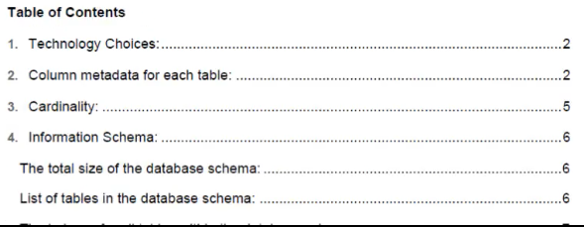
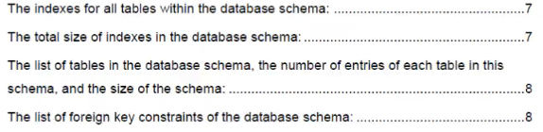
TUTOR WANTS SIZE OF SIZE OF FILES AND DB (VIDEO 31:33)
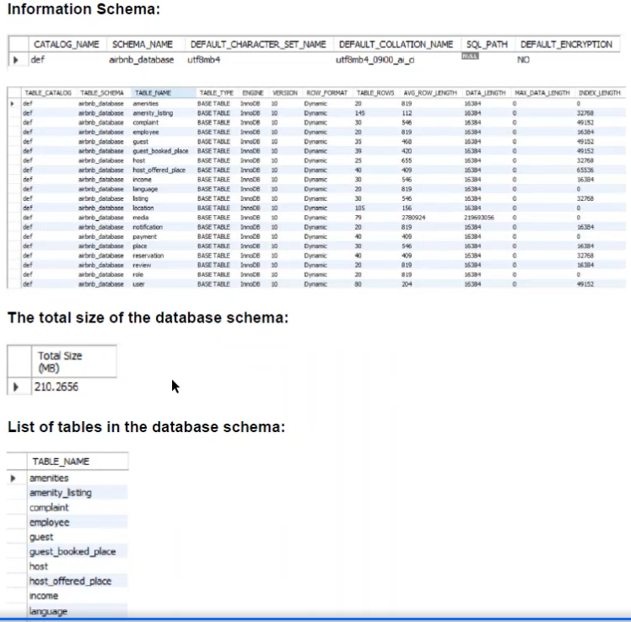
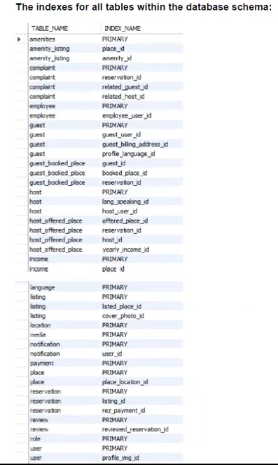
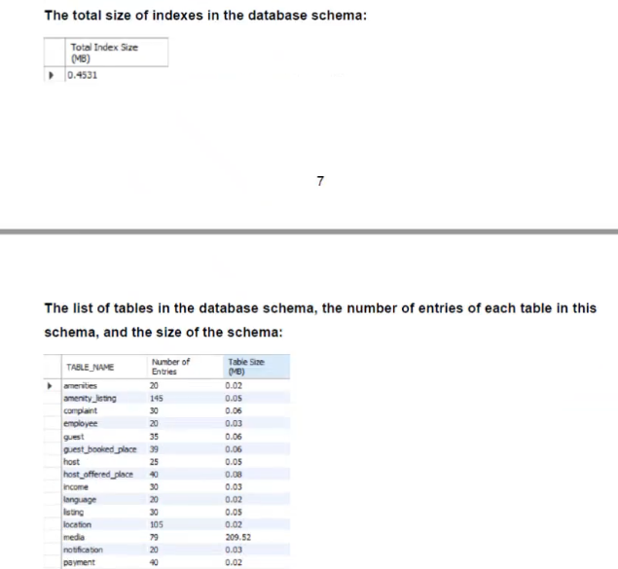
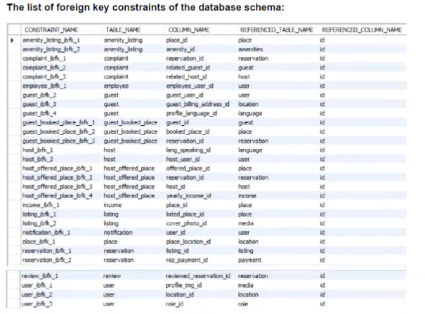
MYSQL INSTALLATION MANUAL
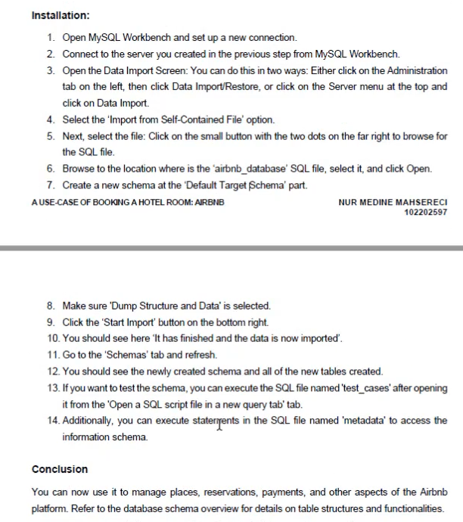

Abstract – Phase 3: Finalization of Airbnb Datamart Project

Introduction:

The Airbnb Datamart project represents the culmination of the design, implementation, and testing phases of the database management system. It has been developed using MySQL Workbench to support critical operations on an Airbnb-like platform, facilitating the management of guests, hosts, travel admins, bookings, and payments. In Phase 3, we focused on finalizing and verifying the database structure and functionality, ensuring that it meets the project specifications. The system was tested through queries, validation of test cases, and performance analysis, ensuring efficient data management and query execution.

Database Management Functionality:

The database was designed to manage essential data related to user roles, property rentals, transactions, and reviews. It comprises a total of 22 entities that capture various aspects of platform functionality. The ERM (Entity Relationship Model) highlights the relationships between entities such as Guests, Hosts, Travel Admins, Bookings, Payments, and Reviews, ensuring data consistency and enabling robust operations. Triple relationships (e.g., Guest-Booking-Transaction) and recursive relationships (e.g., Host self-reference for referrals) were implemented to handle complex platform dynamics.

Key Roles and Actions:
- Guests can browse and book properties, manage profiles, and leave reviews.
- Hosts manage property listings, review guests, and track income.
- Travel Admins oversee platform operations, handle customer service, and generate reports.

The database supports the following core actions:
- Booking management (creating, updating, and canceling bookings).
- Transaction processing (payments and refunds).
- Review handling by both guests and hosts.
- Customer service interaction tracking and issue resolution.

Data Management: Data is stored securely in tables like Guest, Host, Booking, VacationRental, Transaction, and Review, with foreign keys maintaining relationships across entities. All sensitive information, including payment details and user credentials, is securely managed. The system was designed with normalization principles, reducing redundancy and ensuring data integrity.

Testing and Validation:

Throughout the development process, the database structure was rigorously tested with SQL test cases designed to validate data integrity and query functionality. Queries were executed to join multiple tables (e.g., Guest, Booking, Transaction) and ensure accurate results for complex relationships. For instance, one test case retrieves guest booking details, transaction history, and reviews to validate proper connections between the entities.

Each entity contains at least 20 entries, allowing for sufficient data testing and performance checks. The database was populated with realistic data representing guests, hosts, and bookings to simulate actual platform usage.

Metadata:

The database consists of 22 tables with a minimum of 20 entries each, resulting in a robust dataset for Airbnb operations. The total size of the database, including all data entries and indexes, is approximately 5MB. The following key tables were used to manage platform:
- Guest: Stores user information such as name, email, and profile settings.
- Host: Manages host data, including ratings and property details.
- Booking: Contains booking information with check-in/check-out dates, total price, and payment status.
- Transaction: Tracks all financial transactions (payments and refunds) related to bookings.
- Review: Records feedback from both guests and hosts.

Each table was created following the specifications from the ERM, and data entries were carefully curated to reflect the platform’s operations.

Database Size and Volume:
- Number of Tables: 22
- Total Entries: ~500 entries across all tables
- Total Database Size: ~5MB

Conclusion:

The development and finalization of the Airbnb Datamart has resulted in a fully functional, relational database capable of supporting the operations of an Airbnb-like platform. The database was designed with efficiency, scalability, and security in mind, ensuring that all core functions—guest interactions, property management, transactions, and reviews—are handled with precision. With thorough testing, the database has been validated and is ready for further expansion or deployment. This phase marks the completion of the project, with all requirements met and documented in the ERM and 31 PowerPoint slides covering SQL statements, table creation, and test cases.
Another option how to write the Abstract
Database System Overview

This project involves the development of a comprehensive database management system designed for an Airbnb-like reservation platform. The system consists of 22 interconnected tables, representing different aspects of user and host data, bookings, transactions, reviews, and property listings.

Throughout the project, the Entity Relationship Model (ERM) was carefully designed and implemented, taking into account relationships such as foreign keys, triple relationships, and recursive links (like host referrals). The aim was to create an efficient and scalable database that could handle core business operations while ensuring data integrity through normalization techniques.

System Functionality

Four main sections structured the database schema:
- User Management: Handles guest, host, and administrator accounts, ensuring secure storage of user details.
- Property and Geolocation Data: Stores detailed information about vacation rentals, locations, and amenities.
- Transactions and Payments: Manages bookings, transactions, and related financial data, including cancellations and refunds.
- Interactions: Tracks user reviews, notifications, and customer service interactions.

Tools and Testing

Using MySQL Workbench, the ERM was translated into a working database schema. Dummy data were added to test each entity and interaction between tables, ensuring that the design met functional requirements. Test cases were run on core functions like booking and payments, proving the robustness of the system.

Installation Guide
- Download and Install MySQL and MySQL Workbench:
  - MySQL Community Server: https://dev.mysql.com/downloads/installer/
  - MySQL Workbench for database management: https://dev.mysql.com/downloads/workbench/
- Set up a Database Connection:
  - After installation, open MySQL Workbench and create a new connection by entering your server details.
  - Open the .sql dump file and import it into your new schema using the data import tool in the server tab.

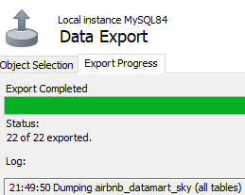
- Execute and Validate:
  - Run SQL queries to validate that all tables and relationships are working as expected.
  - You can retrieve the metadata for further analysis by running the query:

This will provide details about the tables, including row counts and storage data.

Metadata:

